**E Commerce Website**



Submitted in partial fulfilment of the requirements of the degree  
**BACHELOR OF ENGINEERING** IN **COMPUTER ENGINEERING**

By

**Aniket Sharma**

**Soumya Singh**

**Isha Gaonkar**

Supervisor

**Prof. Ranjita Asati**

**Department of Computer Engineering**



**Atharva college of Engineering**

**Malad West, Mumbai - 400 095**

**University of Mumbai  
(AY 2021-22)**

**CERTIFICATE**

This is to certify that the Mini Project entitled **“Student Guide ”** is a bonafide work of **Aniket Sharma (Roll No. 40), Soumya Singh (Roll No. 48), Isha Gaonkar (Roll No. 30),** submitted to the University of Mumbai in partial fulfillment of the requirement for the award of the degree of **“Bachelor of Engineering”** in **“Computer Engineering” .**

Supervisor -**Prof. Ranjita Asati**

Head of Department - **Prof. Suvarna Pansambal**  Principal- **Prof. S. Kallurkar**

**Mini Project Approval**

This Mini Project entitled “Student Guide**”** by

**Aniket Sharma (Roll No. 40),**

**Soumya Singh (Roll No. 48),**

**Isha Gaonkar (Roll No. 30),**

is approved for the degree of **Bachelor of Engineering** in **Computer Engineering.**

**Examiners**

**1.............................................**

(Internal Examiner Name & Sign)

**2................................................**

(External Examiner name & Sign)

Date:

Place:

**Contents**

**Abstract …………………………………………………………. 5**

**Acknowledgments………………………………………………. 6**

1. **Introduction**

**1.1**Introduction

* 1. Motivation

**1.3**Problem Statement & Objectives

**1.4**Organization of the Report

1. **Literature Survey ……………………………………10**

2.1  Survey of Existing System

2.2  Limitation Existing system or research gap

2.3  Mini Project Contribution

1. **Proposed System (e.g. New Approach of Data Summarization )………………………………………… 17**

3.1  Architecture/ Framework

3.2 Flowchart of Website

3.3  Details of Hardware & Software

3.4  Conclusion and Future work.

**Abstract**

This paper has multiple new feature added to the e commerce system. One of the main is the blockchain transaction management system and etc. We have done research on blockchain and implemented it on the website and in turn making it secure for the user. Multiple paper have been mentioned below with summary. This paper will justify the need of the new system in the world of internet which help the economy grow as a whole. This website is made to inspire new developer towards blockchain development.

**Acknowledgement**

We would like to express a deep sense of thanks and gratitude to out project guide Prof. Ranjita Asati for constantly guiding us throughout this project. Her constructive advice and constant motivation have been responsible for the successful completion of this project.

We have been greatly benefitted from the valuable guidance, encouragement and kind supervision given to us throughout this project which helped us to develop the project successfully.

Submitted By,

Aniket Sharma, Roll No. 40

Soumya Singh, Roll No. 48

Isha Gaonkar, Roll No. 30

Under the guidance of

Prof. Ranjita Asati

1. **INTRODUCTION**

**1.1 Introduction**

* There are many e commerce website which can have certain rules and restrictions about you can sell and buy and how you can go about it.
* Our websites is been made to cover a broader spectrum of things that can be sold on or website.
* One of the main features of our website is the blockchain dependent transactions security.
* Blockchain is a system in which a record of transactions made in bitcoin or another cryptocurrency are maintained across several computers that are linked in a peer-to-peer network.
* Blockchain helps the decentralized the transactions and makes it more trustworthy for the seller and the buyer

**1.2 MOTIVATION**

* The concept of e commerce website is very common

and is very difficult to maintain the secrecy and the

Broadness of the things that can be sold on the websites .

* The concept’s of e commerce also tends to get old as new technology are been introduced and are need to be implemented for the betterment of the user and making it more interesting.
* There are many website which have certain privacy and data corruption possibility .
* The user has basically now idea what is happening with his/her data
* This eventually leads to loss of trust of the user in ever aspect of the internet.
  1. **Problem Statement & Objectives**

**Problem Statement :**

The problem are listed below as the

* Already existing e commerce website may cause mis use of the data of the user (i.e. buyer seller and other personal details ).
* User cannot have a certain platform to sell anything and everything on this e commerce website.
* There are no certain website which allow transaction to happen in certain currency (i.e. cryptocurrency)

**Solution: -**

* A website with a decentralized system of transaction management which will leads to gaining more trust of the user in the website and attracting more business towards the company
* Blockchain is the technology which has the developer in crypto market to achieve decentralization and eventually more trust towards It as the new generation comes along
* A broader spectrum of things that can be sold (ie projects, digital assets) and a much broader spectrum of transaction currency (ie crypto currency and many more )

1. **Literature Survey**

**2.1 Survey of Existing System:**

**1)Consumers’ Trust in Electronic Commerce Transactions: The Role of Perceived Privacy and Perceived Security**

**Abstract**

Consumers’ trust in their online transactions is vital for the sustained progress and development of electronic commerce. Our paper proposes that in addition to known factors of trust such a vendor’s reputation, consumers’ perception of privacy and security influence their trust in online transactions. Our research shows that consumers exhibit variability in their perceptions of privacy, security and trust between online and offline transactions even if it is conducted with the same store. We build upon this finding to develop and validate measures of consumers' *perceived privacy* and *perceived security* of their online transactions which are then theorized to influence their trust in EC transactions. We propose that the perceptions of privacy and security are factors that affect the consumers’ trust in the institutional governance mechanisms underlying the Internet. We conduct two distinct empirical studies and through successive refinement and analysis using the Partial Least Squares technique, we test our hypothesized relationships while verifying the excellent measurement properties associated with our instrument. Our study finds that the consumers’ perceived privacy and perceived security are indeed distinct constructs but the effect of perceived privacy on trust in EC transactions is strongly mediated by perceived security. A major implication of our findings is that while the much studied determinants of trust such as reputation of the transacting firm should not be neglected, vendors should also engage in efforts to positively influence consumer perceptions of privacy and security. We discuss the significance of this observation in the context of increasing importance in acquiring customer information for personalization and other online strategies.

**Summary:**

The paper written by Ramnath K. Chellappa is the analysis of the people more certainly the buyers on the e commerce website. The research is done with the help of different hypothesis. These hypothesis were tested and studies where done on the results obtained. In total of 3 studies done with respective to the hypothesis and to verify the convergent, discriminant and factorial validity of our study involving a sum total of 217 subjects. Different set of data were obtained and were used to analyse the process. At the end the conclusion was that the consumer requires a significant amount of trust to be assure of the transactions made by him / her. That trust is required in both offline and online commerce. This trust in the field of e commerce can be obtained by providing more transparency about the working and what kind of data is been taken by the website at the end of an transaction and how safe are they.

**2) Future of E-commerce in India**

**Abstract**

Electronic commerce (e-commerce) as part of the information technology revolution became widely used in the world trade in general and Indian economy in particular. With advancements in technology, there have been changes in the methodology for business transactions. India, being a rapid adaptor of technology is apace with the current scenario of electronic data exchanges and has taken to e-commerce. E-commerce stands for electronic commerce and pertains to trading in goods and services through the electronic medium. India is showing tremendous growth in the Ecommerce. The low cost of the PC and the growing use of the Internet is one of reasons for that. There is a growing awareness among the business community in India about the opportunities offered by e-commerce. Textile Industry is second largest industry in the country contributing 14% to GDP. E-commerce and electronic applications in automation has brought in tremendous growth in India. E-commerce is connecting rural India for the business hence develop village economy. The future does look very bright for ecommerce in India. India is showing tremendous growth in the E- business. India has an internet user base of over 100 million users. The penetration of e-business is low compared to markets like the US and the UK but is growing at a much faster rate with a large number of new entrants. India is yet to witness a breakthrough E-commerce success story particularly in online retail. E-commerce creates new opportunities for business; it also creates new opportunities for education and academics line. It raises key challenges that are being faced by consumers relating to e-commerce viz., Ethical issues, Perceptions of risk in e-service encounters, challenges for e-business education and legal system. The new Innovative Technologies in Electronic and IT applications is backbone of the Industry development. This can happen only when E-commerce supplements and compliments development of the Engineering Industry and large-scale Quality manufacturing happens in India. India needs to promote E-commerce business to develop rural India by developing effective communication to map value of the goods produced and make available goods and services at low cost to the consumers. Textile garment Industry has got tremendous support by E-commerce by online web portal but consumer needs to be taken into confidence by educational program in rural India

**Summary**

This paper reviews the literature on the basis of secondary data collected from various references which already exist in published from such as articles, books, newspaper, national/ international journal, magazine, annual reports, government and non-government publication and company official websites, etc. This paper reviews the literature on the basis of secondary data collected from various references which already exist in published from such as articles, books, newspaper, national/ international journal, magazine, annual reports, government and non-government publication and company official websites, etc. This paper is basically the study about how the e commerce has grown over the years in India. The paper also has a mentioning about how covid 19 and the lockdown restrictions in India has effected the e commerce and online shopping websites.

The paper also has a good mentioning about the different trends and opportunities in India of E-commerce in India. A quote from paper ‘Innovation and individuals are continually developing, and since e-commerce unites everything, we are continually going to be looking toward what's to come’. In conclusion the paper states that as the internet increases the industries of the e commerce grows with it.

**3)** A Survey of Blockchain Security Issues and Challenges

**Abstract**

Blockchain technologies is one of the most popular issue in recent years, it has already changed people’s lifestyle in some area due to its great influence on many business or industry, and what it can do will still continue cause im- pact in many places. Although the feature of blockchain technologies may bring us more reliable and convenient services, the security issues and challenges behind this in- novative technique is also an important topic that we need to concern.

**Summary**

The paper written by authors Iuon-Chang Lin and Tzu-Chun Liao justifies why the blockchain is the hot topic in recent times and have great interest of the new generation. The paper gives and proper understanding of how the blockchain works. It also has a segment where the user can easily understand how the blockchain is created and how the hash value have such importance in blockchain development. The also tells about the pros and cons of blockchain development . the author at the end is in the favour of the blockchain development as the pros have outdone the cons.

**2.2 Literature survey: Existing system**

There are right now innumerable E commerce website on internet right now. But there are none which have blockchain based transacting system.

All the E commerce website, have a traditional system to analyse the data and use it which can cause mis-use of the data and causing distrust between the user and the interface.

E commerce website is one of the most trending things on the internet and can go on the new level with the new approaches. New generation has new demands and wants to be up to date with trending technology in each and every fields possible. Nowadays, e commerce is only used to sell and buy certain commodities, but a different approach can help the buyer and seller to acquire with new market system and with new market system it is also required to have a better security and encrptyion. There are also certain limitation about what currency is to be used which is good as it gives a certain group of people a common ground to do transaction in. But by using a new currency which is not withhold by any one country and can be accessed by anyone in the world such as cryptocurrency and other digital assets can also be used for the transactions and this will be an upside as it will attract the new generation by gaining there interest and intron causing the growth of e commerce website.

**2.3 Literature survey: Proposed system**

We will be creating the e commerce website which will be having a decentralized trans actioning system. By decentralizing the system, as there won’t be any particular one person at the top and therefore the user themselves will be responsible for their data. This leads to less mis use of data and personal information of the user and therefore gaining more trust of the user in the website.

The website will also provide the user with an option of selling anything and everything on this website. This will be an new platform for the user to buy and sell things from **project to digital assets.**

E commerce website generally have a certain restriction on which currency the transaction is going to happen . To move this bar of restriction the website will also allow the user to make transaction on **cryptocurrency.**

**3. Proposed Architecture**

**3.1 Architecture**

This project “e commerce website ”is a website which will help the user to initiate the transactions on blockchain based system. In this project all the frames are designed in VS code using HTML, CSS, Javascript. The backend is designed using Python, Flask and My SQL Database.

**3.2 Flowchart of Website:**

Thanks For Buying from Mr.E-commerce

Downloading the details using the password received one mail

Sending email to user for the password

Authorizing the payment from ace coins wallet

Adding Transaction Details

Dashboard (Transaction History)

BUY NOW

Product details

(Pricing and ratings)

HOME PAGE

(Product Recommendation)

NEW USER/LOGIN

**3.3 Details of Hardware & Software**

An editor like VS code ,pycharm for windows operating system . Live server to see the result. The programmer can choose the editor of their choice.

From the user point of view, need is only to click on the link

**Software Requirement** –

Operating System: “Microsoft VS Code\Code.exe" File version: 1.62.3.0

Pycharm 2021.3.3

**Hardware Requirement** –

Memory (RAM): 1 GB or higher

Processor: Pentium IV or higher

Hard Disk: 500 MB require

**Screenshot of Implementation:**

Login Page

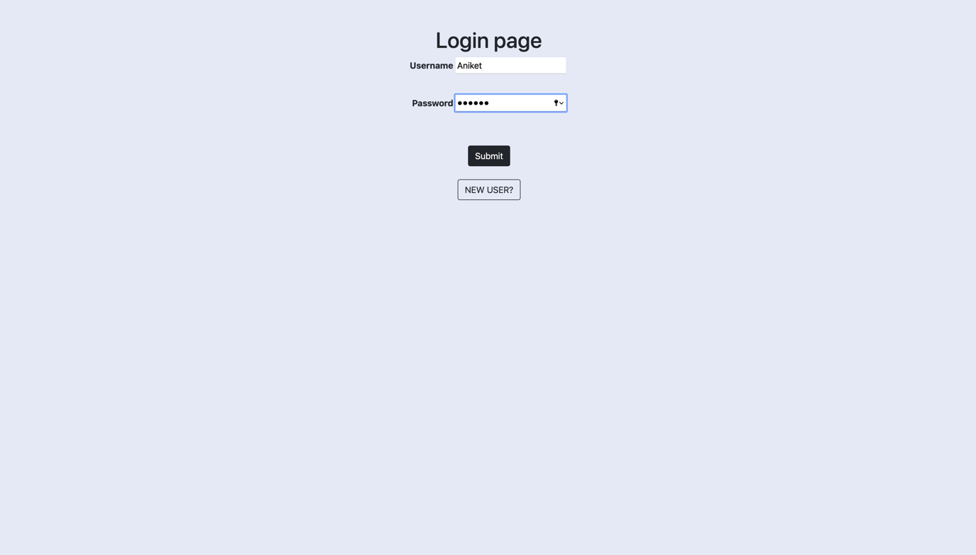

**Home Page:**

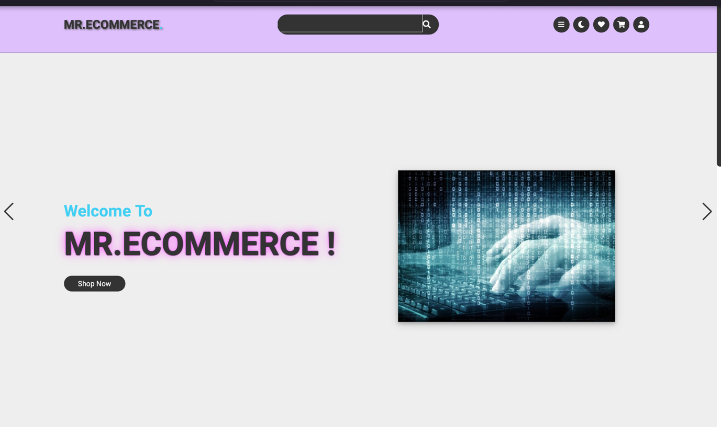

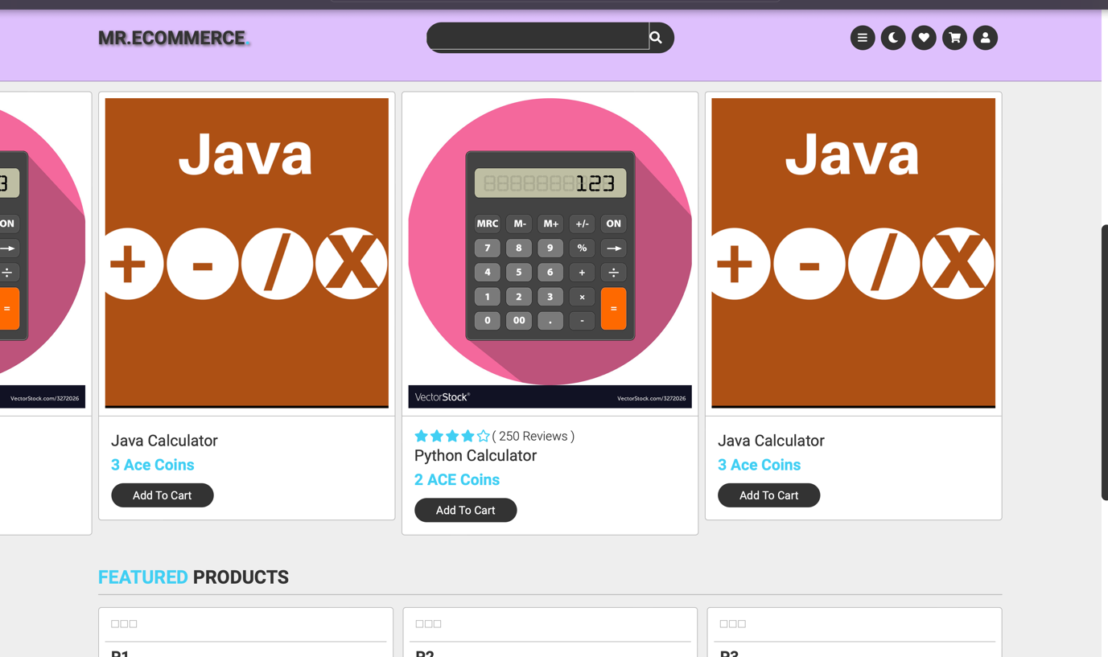

**Dashboard:**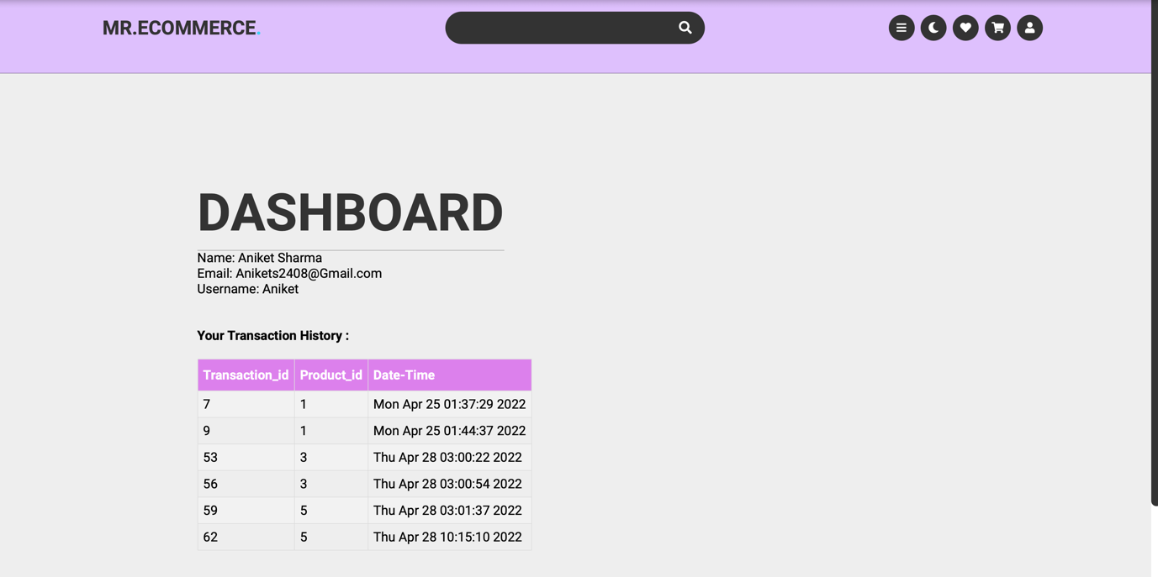

**Product Page:**

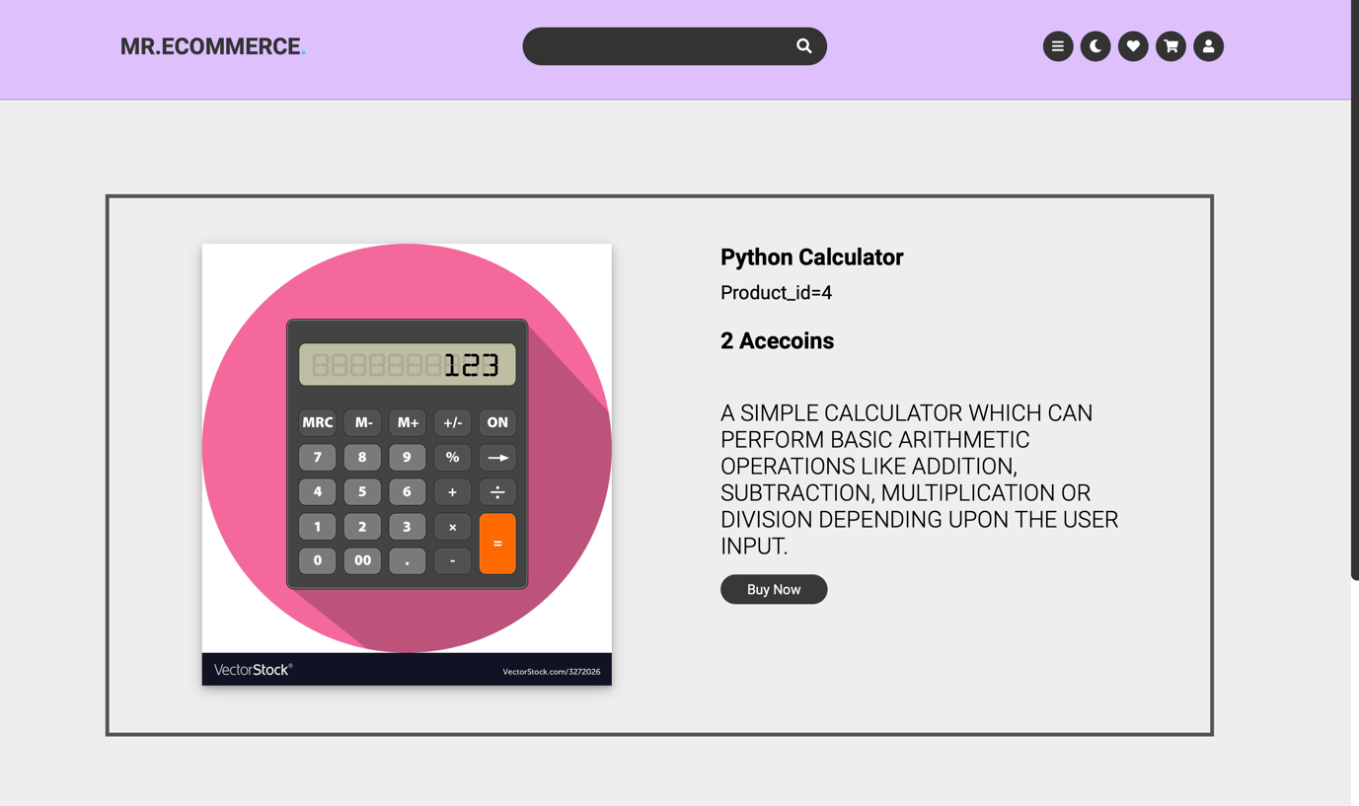

**3.4 Conclusion and Future work.**

We have successfully added different a payment option using cryptocurrency which is not seen in ecommerce website. We have also added authentication page made with the help of python and Mysql and many other tools. The project helped us to understand the pros and cons of development of Ecommerce website’s. This project has also helped us to understand the transaction system and how we can use the blockchain technology in transaction systems.

**Future works**

We look forward to make this project more secure and add new products from time to time and make the website more relevant and user friendly as much as possible.

**References:**

1) **Consumers’ Trust in Electronic Commerce Transactions: The Role of Perceived Privacy and Perceived Security**

By **Ramnath K. Chellappa**

2) **Future of E-commerce in India**

3) A Survey of Blockchain Security Issues and Challenges

Iuon-Chang Lin1,2 and Tzu-Chun Liao2

4) <https://youtu.be/pYasYyjByKI>

5) [https://www.w3schools.com](https://www.w3schools.com/)

6) <https://www.udemy.com/course/python-for-beginners-course-/learn/lecture/21367924#content>